Gilder Lehrman: Great Decisions in Foreign Policy Mrs. Scherer
Unit 1: World War I

This Day in History
World War I: Newscast Project
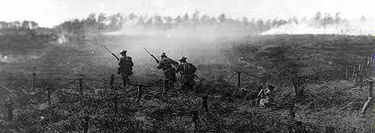
WWI remains one of the bloodiest and most destructive wars ever. Its global impact on humanity was devastating. The allied and central powers leading the battles -- Germany, France, and Britain - did not make any great gains, despite their efforts to advance their positions, and suffered and inflicted extraordinary casualties. The Battle of Verdun, for example, lasted nine months and resulted in 300,000 dead and 750,000 injured. There are TWO parts to this assignment.

Your Assignment:

- You will be assigned one day in WWI history.
- You and your news team will create a 10 minute news program covering that day.
    - Christmas Day Truce
    - Battle of Gallipoli
    - Armistice Day - Last Day of the War

You and your group will present the battle as a newscast as part of “News of the Day”.
You will sit in front of the smart board like news journalists and give the news of the battle you are assigned.
The smart board should show appropriate photos or tag lines that coincide with what you are reporting.

Roles:
1 or 2 newscasters
1 cameraman (to coincide the smartboard with the news report)
1 on the ground reporter to give a report and take questions from the newscasters.
(If your group has more than 4 people then you can have 1 person give an opinion or act as an expert on an issue you want to ask them about.)

Research:
When researching end each google search with site:edu
This will bring you to more scholarly research for content to write your newstorty
Create a Bibliography: (keep track of all your research on a separate page)

Dean, Cornelia. "Executive on a Mission: Saving the Planet." The New York Times, 22 May 2007, www.nytimes.com/2007/05/22/science/earth/22ander.html?_r=0. Accessed 29 May 2019.
Ebert, Roger. Review of An Inconvenient Truth, directed by Davis Guggenheim. Ebert Digital LLC, 1 June 2006, www.rogerebert.com/reviews/an-inconvenient-truth-2006. Accessed 15 June 2019.

News Idea Board: Brainstorm with your group for ideas to cover in your news story

• where the battle occurred,
• what led to its occurrence,
• battle conditions, such as the weather
• who was involved,
• how many casualties,
• types of weapons used,
• the end result of the war (who "won" the battle and its effect on everything
around it, including civilians).

