Regents Review Quizzes Mrs. Lisa Scherer-JFK HS

**Colonial Era**

1. In the Colonial Era, developments such as the New England town meetings and the establishment of the Virginia House of Burgesses represented
   1. Colonial attempts to build a strong national government
   2. Efforts by the British to strengthen their control over the colonies
   3. Steps in the growth of representative democracy
   4. Early social reform movements
2. Which fundamental political idea is expressed in the Declaration of Independence?
   1. The government should guarantee every citizen economic security
   2. The central government and state governments should have equal power.
   3. If the government denies its people certain basic rights, that government can be overthrown.
   4. Rulers derive their right to govern from God and are therefore bound to govern in the nation’s best interest
3. The Mayflower Compact is important to the concept of a democratic society because it represents
   1. An effort by the colonists to use force to resist the King
   2. A clear step toward self-government
   3. An early attempt to establish universal suffrage
   4. An attempt by the colonists to establish freedom of religion
4. The British system of mercantilism was opposed by many American colonists because it
   1. Placed quotas on immigration
   2. Discouraged the export of raw materials to England
   3. Placed restrictions on trading
   4. Encouraged colonial manufacturing
5. During the Revolutionary War period, Thomas Paine’s Common Sense was important because it
   1. Described a military plan for the defeat of England
   2. Convinced many Americans who had been undecided to support independence
   3. Contained a detailed outline for a new form of government
   4. Argued for the addition of a bill of rights to the Constitution
6. Court decisions in the trial of John Peter Zenger (1735) and the case of New York Times Co. v. United States (1971) strengthened
   1. Freedom of religion
   2. Freedom of the press
   3. Due process rights
   4. The right to counsel
7. Which statement is most accurate about the movement for independence in the thirteen colonies?
   1. The independence movement began soon after the founding of the Plymouth Colony.
   2. Protests against British colonial policies gradually led to demands for independence.
   3. The King of England required the colonists to become economically self-sufficient.
   4. The movement for independence was equally strong in all of the colonies.
8. The main reason Great Britain established the Proclamation Line of 1763 was to
   1. Avoid conflicts between American colonists and Native American Indians
   2. Make a profit by selling the land west of the Appalachian Mountains
   3. Prevent American industrial development in the Ohio River valley
   4. Allow Canada to control the Great Lakes region
9. During the colonial period, the British Parliament used the policy of mercantilism to
   1. Limit manufacturing in America
   2. Prevent criticism of royal policies
   3. Deny representation to the colonists
   4. Force colonists to worship in the Anglican Church
10. Which heading best completes the partial outline below? I. ____________________________________ A. Committees of Correspondence B. Nonimportation Agreements C. Boston Tea Party D. First Continental Congress
    1. Protests Against Slavery in the American Colonies
    2. British Parliamentary Actions to Punish Colonial Americans
    3. Colonial Responses to British Mercantile Policies
    4. Colonial Attempts to End the British Policy of Salutary Neglect

**Formation of Government**

1. The writers of the Constitution corrected an economic weakness under the Articles of Confederation when they
   1. Granted Congress the power to levy and collect taxes
   2. Created an executive branch headed by the president
   3. Granted the president the authority to negotiate treaties
   4. Created a two-house legislature
2. Which document is most closely associated with John Locke’s social contract theory of government?
   1. Albany Plan of Union
   2. Declaration of Independence
   3. Treaty of Paris (1783)
   4. Sedition Act of 1789
3. A strict interpretation versus a loose interpretation of the Constitution was most evident in the debate over
   1. Creation of the Bank of the United States in 1791
   2. Decision to declare war on Great Britain in 1812
   3. Annexation of Florida in 1821
   4. Issuance of the Monroe Doctrine in 1823
4. Which headline illustrates the use of the unwritten Constitution?
   1. **“Washington Establishes a Cabinet”**
   2. **“House Votes to Impeach Andrew Johnson”**
   3. **“Senate Rejects the Treaty of Versailles”**
   4. **“President nominates John Roberts for Supreme Court”**
5. Judicial review is most accurately described as the power of the
   1. President to override a decision of the Supreme Court
   2. State courts to overturn decisions of the Supreme Court
   3. Senate to approve all presidential appointments to federal courts
   4. Supreme Court to determine the constitutionality of laws
6. In Colonial America, the House of Burgesses, the Mayflower Compact, and town hall meetings were all developments that led to the
   1. Regulation of trade with Native American Indians
   2. Protection of the rights of women
   3. Elimination of the power of the upper classes
   4. Creation of representative government
7. Which constitutional principle best protects the public from abuse by one branch of government?
   1. Equality
   2. Federalism
   3. Executive privilege
   4. Checks and balances
8. Many critics of the electoral college system point out that it
   1. Penalizes the states with the smallest population
   2. Encourages the formation of minor political parties
   3. Grants too much influence to the United States Senate
   4. Might not select the candidate with the largest number of popular votes
9. Critics of the Articles of Confederation argued that it
   1. Imposed unfair taxes on the states
   2. Used a draft to raise a national army
   3. Provided a strong system of federal courts
   4. Placed too much power in the hands of the state
10. The Magna Carta and the English Bill of Rights were significant influences on United States constitutional development because they
    1. Provided suffrage for all men and women
    2. Placed limits on the powers of the government
    3. Called for the abolition of slavery
    4. Supported the development of federalism

11. In the United States, the use of implied powers, the amending process, and Supreme Court interpretations have resulted in

a. a general loss of individual rights

b. a strengthening of the principle of separation of powers

c. the Constitution being adapted to fit changing times

d. the limiting of Presidential power in domestic affairs

12. The authors of the United States Constitution believed that the voice of the people should be heard frequently. Which part of the Government was instituted to respond most directly to the will of the people?

1. Senate
2. House of Representatives
3. Supreme Court
4. Presidency

13. In the 1780’s, many Americans distrusted a strong central government. This distrust is best shown by the

1. lack of debate over the ratification of the United States Constitution
2. plan of government set up by the Articles of Confederation
3. development of a Federal court system
4. constitutional provision for a strong President

14. Which quotation from the United States Constitution provides for a Federal system of government?

* 1. “He shall have power . . . with the advice and consent of the Senate, . . . and . . . shall appoint . . .“
  2. “Every bill . . . shall, before it becomes a law, be presented to the President of the United States; . . ."
  3. “The powers not delegated to the United States . . . are reserved to the states . . .“
  4. “Full faith and credit shall be given in each state to the public acts, records, and judicial proceedings of every other state.”

15. The system of checks and balances is best illustrated by the power of

* 1. the President to veto a bill passed by Congress
  2. Congress to censure one of its members
  3. a governor to send the National Guard to stop a riot
  4. state and Federal governments to levy and collect taxes

16. Which Presidential action is an example of the unwritten constitution?

* 1. appointing Justices to the Supreme Court
  2. granting pardons for Federal crimes
  3. submitting a treaty to the Senate for ratification
  4. consulting with the Cabinet

17. A lasting impact of the United States Supreme Court under Chief Justice John Marshall is that the Court’s decisions

* 1. extended the Bill of Rights to enslaved persons
  2. expanded the power of the Federal Government
  3. restricted the authority of Congress
  4. promoted the views of the President

18. Which argument did the authors of the United States Constitution use when they insisted that revenue bills originate in the House of Representatives?

* 1. Frequent elections would make members of the House more responsive to the wishes of the voters.
  2. Members of the House would have a superior understanding of economics.
  3. The national budget should be determined solely by the House of Representatives.
  4. Political parties would have less influence on Members of the House than on Senators.

19. Which action was necessary to change from the indirect to the direct election of United States Senators?

* 1. ratification of a constitutional amendment
  2. passage of a Federal law
  3. a Supreme Court decision
  4. a national referendum

20. The flexibility of the original United States Constitution is due mainly to

* 1. its provision for the amending process and judicial interpretation
  2. its guarantees of freedom and justice for all people
  3. the ability to create new branches of government as needed
  4. the willingness of the states to accept Federal control

**Federalist Era, Age of Jackson, Manifest Destiny**

1. The speakers below are discussing foreign policies that the United States has followed at various times. Base your answers on their statements and on your knowledge of social studies.

***Speaker A:*** Steer clear of permanent alliances with any portion of the foreign world.

***Speaker B:*** The United States will give economic aid to needy countries anywhere in the world, but will not provide military aid.

***Speaker C:*** The United States must prevent the growth of communism.

***Speaker D:*** The United States can take over other countries to help them become more like us.

Which speaker states a policy most similar to the foreign policy advice given by President George Washington in his Farewell Address?   
1. A  
2. B  
3. C  
4. D

2. When John Marshall was Chief Justice, United States Supreme Court decisions tended to strengthen the power of   
1. The National Government  
2. State and local governments  
3. Labor unions  
4. Trusts and monopolies

3. A major reason for the issuance of the Monroe Doctrine (1823) was to   
1. Discourage United States trade with Latin America  
2. Defend the Panama Canal from Great Britain  
3. Prevent further European colonization in the Caribbean region  
4. Provide economic aid to Latin American nations

4. "Our true policy is to steer clear of permanent alliances …" -George Washington

President Washington made this statement to warn against United States involvement in   
1. European military conflicts  
2. International trade  
3. The race for overseas colonies  
4. Westward expansion

5. Alexander Hamilton urged Congress to pass a protective tariff to encourage the growth of  
1. Labor unions  
2. Manufacturing   
3. Agriculture   
4. Slavery

6. During the presidency of Andrew Jackson, the spoils system resulted in   
1. Federal laws being nullified by the states  
2. Elected officials rewarding their supporters with government jobs  
3. All free males being given the right to vote  
4. The end of political corruption in the federal government

7. The legal basis for the United States purchase of the Louisiana Territory was the  
1. Power granted to the President to make treaties   
2. President’s power as Commander in Chief   
3. Authority of Congress to declare war   
4. Senate’s duty to approve the appointment of ambassadors

8. The Louisiana Purchase had great geographic significance for the United States because it   
1. Reduced British control of North America   
2. Focused the United States on westward expansion   
3. Extended United States control over Mexico   
4. Decreased tensions with Native American Indians

9. When President Thomas Jefferson acquired the Louisiana Territory from France, he demonstrated that he had modified his belief that

1. The Constitution should be strictly interpreted   
2. The federal government should limit individual rights   
3. Adding territory would lead to regional rivalries   
4. Commercial development was the main goal of the federal government

10. Manifest Destiny was used to justify an American desire to

1. Limit the number of immigrants entering the country   
2. Control the area located east of the Appalachian Mountains   
3. Expand the United States to the Pacific Ocean   
4. Warn European countries against colonizing Latin America

Regents Review: Sectionalism and Civil War

1. Which argument did President Abraham Lincoln use against the secession of the Southern States?

1. Slavery was not profitable
2. The government was a union of people and not of states.
3. The Southern States did not permit their people to vote on secession.
4. As the Commander in Chief, he had the duty to defend the United States against foreign invasion.

2. A major result of the Civil War was that the

1. Economic system of the South came to dominate the United States economy
2. Federal Government’s power over the States was strengthened
3. Members of Congress from Southern States gained control of the legislative branch
4. The Nation’s industrial development came to a standstill

3. Sectional differences developed in the United States largely because

1. The Federal Government adopted a policy of neutrality
2. Economic conditions and interests in each region varied
3. Only northerners were represented at the Constitutional Convention
4. Early Presidents favored urban areas over rural areas

4. Before the Civil War, slavery expanded in the South rather than in the North because

1. The Constitution contained a clause that outlawed the importation of slaves into the Northern states
2. Congress passed a law forbidding slavery in the North
3. Northern states passed affirmative action legislation
4. Geographic conditions in the South encouraged the development of large plantations

5. Which phrase best completes the title for the partial outline shown below? I. Reasons for the ______________________

A. Increasing sectionalism

B. Disagreements over states’ rights issues

C. Breakdown of compromise

D. Election of 1860

1. Start of the Revolutionary War
2. Adoption of the Bill of Rights
3. Failure of the Whiskey Rebellion
4. Secession of Southern States from the Union

6. "A house divided against itself cannot stand. . . . I do not expect the Union to be dissolved; I do not expect the house to fall; but I do expect it will cease to be divided. It will become all one thing, or all the other. . . .” -Abraham Lincoln, 1858 The “divided house” referred to in this speech was caused primarily by

1. Expansionism
2. War with Mexico
3. Slavery
4. The suffrage movement

7. The Civil War affected the northern economy by

1. Causing a severe depression
2. Increasing unemployment rates
3. Decreasing demand for agricultural products
4. Stimulating industrialization

8. The North’s rapid economic growth during the Civil War was stimulated by

1. The elimination of taxes on defense industries
2. A reduction in the number of immigrants
3. Increased government demand for many products
4. Enslaved persons filling industrial jobs

9. Prior to the Civil War, abolitionists reacted to the situation described in the poster by

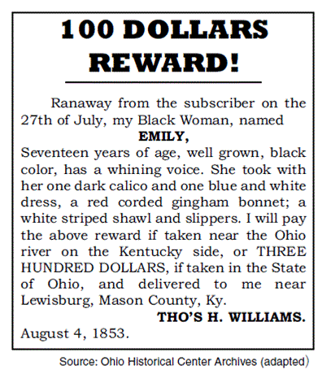

1. Supporting the Underground Railroad
2. Opposing the Emancipation Proclamation
3. Banning freed slaves from Northern states
4. Proposing a stricter fugitive slave law

10. In the 1850s, why did many runaway slaves go to Canada?

1. They feared being drafted into the Northern army.
2. The Fugitive Slave Act kept them at risk in the United States.
3. More factory jobs were available in Canada.
4. Northern abolitionists refused to help fugitive slaves.

**Regents Review: Reconstruction and Southern Redemption**

“… With malice toward none; with charity for all; with firmness in the right, as God gives us to see the right, let us strive on to finish the work we are in; to bind up the nation’s wounds; to care for him who shall have borne the battle, and for his widow, and his orphan—to do all which may achieve and cherish a just, and a lasting peace, among ourselves, and with all nations.

— President Abraham Lincoln, 1865

1. This statement by President Lincoln contributed to disagreements over the

(1) Continuation of a military draft

(2) Provision of free land to settlers

(3) Negotiations with foreign nations after the Civil War

(4) Treatment of the former Confederate states and their leaders

1. After the Civil War, the sharecropping system emerged in the South primarily as a way to

(1) Diversify agricultural production

(2) provide a labor supply to plantation owners

(3) give forty acres of land to freedmen

(4) guarantee economic equality for African Americans

1. President Abraham Lincoln’s plan for Reconstruction after the Civil War included

(1) restoring the social conditions that existed before the war began

(2) conducting trials for former Confederate leaders

(3) destroying the economic and social power of the Southern planters

(4) reuniting the nation as quickly as possible

1. After the Civil War, freedmen in the South had difficulty improving their economic condition because

(1) literacy for formerly enslaved persons was prohibited

(2) migration of factory workers from Northern cities had created competition for jobs

(3) the federal government confiscated their 40- acre grants

(4) the system of sharecropping kept them in a cycle of poverty

1. After the Civil War, the purpose of adding the 13th, 14th, and 15th amendments to the Constitution was to

(1) grant civil and political rights to Native American Indians

(2) allow women to become full citizens

(3) guarantee African Americans equal treatment under the law

(4) extend constitutional rights to new territories

1. Which actions did Southern States take to keep African Americans from exercising the rights guaranteed in this amendment?

(1) suspending habeas corpus and denying women the right to vote

(2) collecting poll taxes and requiring literacy tests

(3) establishing religious and property-holding requirements for voting

(4) passing Black Codes and establishing segregated schools

1. What was a result of the disputed presidential election of 1876?

(1) Reconstruction ended as federal troops were removed from the South.

(2) Slavery was reestablished in the South by state legislatures.

(3) New state laws were passed in the South to guarantee equal rights for African Americans.

(4) A constitutional amendment was adopted to correct problems with the electoral college

system.

1. Following the Civil War, fewer immigrants settled in the South because

(1) most of the new arrivals chose to settle on the Great Plains

(2) freedmen had been given most of the available farmland in the South

(3) jobs were more plentiful for immigrants on the West Coast

(4) more factories that employed unskilled laborers were located in the North

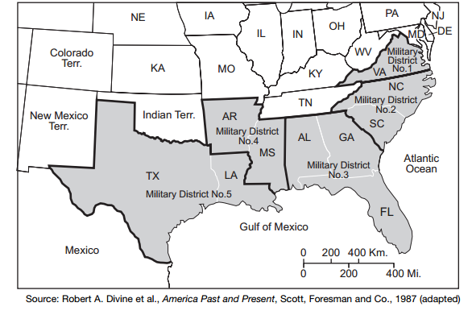

1. The military districts shown on the map were created during Reconstruction to

(1) create economic and social equality in the South

(2) pay for the physical rebuilding of the South

(3) move Native American Indians to reservations

(4) govern the former Confederate states

“The right of citizens of the United States to vote shall not be denied or abridged by the United States or by any State on account of race, color, or previous condition of servitude. . . .”

— 15th Amendment, Section 1, United States Constitution, 1870

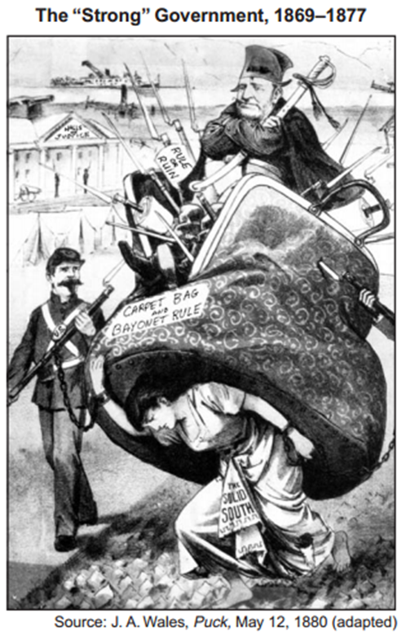

1. What is the main idea of this cartoon from the Reconstruction Era?

(1) Southern society was oppressed by Radical Republican policies.

(2) Military force was necessary to stop Southern secession.

(3) United States soldiers forced women in the South to work in factories.

(4) Sharecropping was an economic burden for women after the Civil War

Regents Review: Closing the West, Granger and Populist Movements

1.  In the 1870s, the Granger Movement was organized to promote the interests of

1)      Suffragists

2)      Farmers

3)      Factory workers

4)      Recent immigrants

2. In the period from 1860 to 1890, which experience was shared by most Native Americans living in western states?

1) They maintained control of their traditional lands.

2) They benefited economically from government policy.

3) They became farmers and small business owners.

4) They were forced to live on reservations.

     3.  In the late 1800’s, the goal of the Federal Government’s policy toward Native American Indians was to

1) Destroy tribal bonds and thus weaken their traditional cultural values

2) Grant them full citizenship and due process

3) Give their tribal groups authority over their own affairs

4) Increase the land holdings of western tribes

4. The aim of the Dawes Act of 1887 was to

  1)  Restore previously taken land to Native American Indian tribes

  2) Maintain traditional Native American Indian cultures

  3) Assimilate Native American Indians into American culture

  4) End all governmental contact with Native American Indians

  5. The purpose of the Homestead Act of 1862, which provided free federal land, was to

  1) Encourage settlement of the West

  2) Set up reservations for Native American Indians

  3) Establish land-grant agricultural colleges

  4) Assist in the construction of transcontinental railroads

 6. The Populists believed that most of the United States economic problems would be solved by establishing

1) Currency reform

2) Postal savings banks

3) A national property tax

4) A renewed policy of open immigration

  7. A main goal of the Granger movement of the 1870’s and 1880’s was to

1) Force the railroads to lower freight rates

 2) Reduce the rate of inflation

 3) Strengthen labor union

 4) Improve living conditions in urban slums

8.  Although the Populist Party failed to elect its candidates to the Presidency, some of the Party’s aims were later achieved by the

1) Adoption of the gold standard

2) Elimination of racial segregation laws in the South

3) Creation of a graduated income tax and the direct election of Senators

4) Establishment of higher protective tariffs on manufactured goods

9. -Free and unlimited coinage of silver

-Government ownership of railroads

-Graduated income tax

Which of these political parties first proposed these reforms in its platform?

1)      Republican Party in 1876

2)      Populist Party in 1892

3)      Bull-Moose Party 1912

4)      Democratic Party in 1932

10.  What common problem did farmers of the 1890s and farmers of the 1920s face?

             1) Failure to plant enough crops to meet local needs

             2) Government over regulation of farming

             3) Low tariffs on crops

             4) Overproduction compared to consumer demand

**Regents Review: Gilded Age**

1)“Prices and wages should be determined by the marketplace.” The author of this statement would most probably support

1. government ownership of utilities
2. minimum-wage laws
3. wage and price controls
4. laissez-faire capitalism

2) In the United States, industrial unions of the 1880’s and of the 1980’s had similar goals in that both campaigned for

1. national health insurance
2. better unemployment insurance
3. greater job security and higher wages
4. wage and price freezes

3) Nativism in the late 19th century was motivated primarily by

1. hostility toward immigrant workers
2. the need to reduce overcrowding in western states
3. cultural conflicts with Native American Indians
4. the migration of African Americans to northern cities

4) A common characteristic of third political parties in the United States is that they

1. tend to focus on one person or one issue
2. come into existence only during periods of corruption
3. have dealt mainly with foreign policy issues
4. have frequently forced Congress to decide Presidential elections

5) Which situation brought about the rapid growth of industry between 1865 and 1900?

1. high worker morale resulting from good wages and working conditions
2. availability of investment capital
3. establishment of western reservations for Native American Indians
4. decline in the number of people attending schools

6) Laws requiring individuals to pass civil service examinations to obtain government jobs were enacted to

1. eliminate patronage and corruption in government hiring
2. allow the government to compete with private industry for employees
3. support the development of public employee labor unions
4. encourage the growth of local political parties

7) Jacob Riis, Jane Addams, and Margaret Sanger are most closely associated with efforts to

1. educate and train formerly enslaved persons
2. preserve the natural environment
3. advance the interests of organized labor
4. improve conditions for the poor

8) Which 19th-century business practice does this cartoon illustrate?

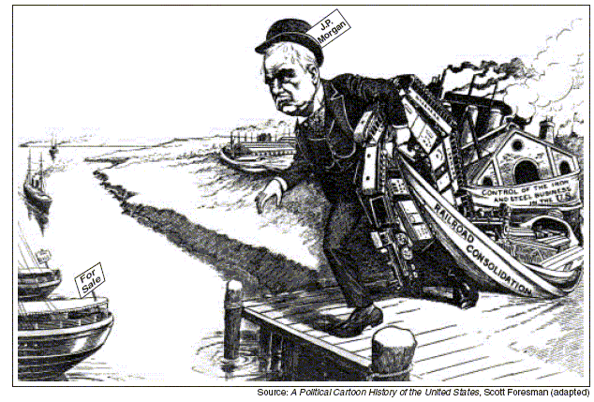

1. forming cooperatives
2. establishing trade zones
3. creating monopolies
4. expanding global markets

9) During the late 1800s, industrialization in the United States led to

1. the growth of the middle class
2. an overall decline in labor union membership
3. the creation of affirmative action programs
4. a decrease in the use of natural resources

10) What was the main benefit that labor unions of the late 19th century gained for their members?

1. job security
2. improved wages and hours
3. paid vacations
4. health insurance

**Regents Review: Imperialism**

1. The Monroe Doctrine declared that the United States would
   1. Prevent the establishment of new European colonies anywhere in the world
   2. Help colonies in North and South America adopt a democratic form of government
   3. View the European interference in the Americas as a threat to the national interest of the United States
   4. Prevent other nations from trading with South American nations
2. Why did the United States formulate the Open Door policy toward China?
   1. To develop democratic institutions and practices in China
   2. To prevent a European and Japanese monopoly of Chinese trade and markets
   3. To establish a military presence in Chinese mainland
   4. To support Japanese efforts to industrialize China
3. Involvement in the Spanish- American War, acquisition of Hawaii, and introduction of the Open Door policy in China were actions taken by the United States Government to
   1. Establish military alliances with other nations
   2. Gain overseas markets and sources of raw materials
   3. Begin the policy of manifest destiny
   4. Support isolationist forces in Congress
4. United States annexation of the Philippines (1898) and military involvement in Vietnam (1960’s and 1970’s) are similar because in each event the United States
   1. Achieved its long-range foreign policy objectives
   2. Put the domino theory into action
   3. Demonstrated the strength and success for its military power
   4. Provoked domestic debate about its involvement in the internal affairs of other nations
5. Which United States policy is most closely associated with the annexation of Hawaii and the Philippines?
   1. Neutrality
   2. Isolationism
   3. Imperialism
   4. International cooperation
6. Yellow journalism created support for the Spanish-American War by writing articles about the
   1. Political popularity of William Jennings Bryan
   2. Efforts of the United States to control Mexico
   3. Destruction of United States sugar plantations by Hawaiians
   4. Sinking of the United States battleship Maine in Havana Harbor
7. Which factor is most closely associated with the decision of the United States to declare war on Spain in 1898?
   1. Isolationist policy
   2. Labor union pressure
   3. Yellow journalism
   4. Unrestricted submarine warfare
8. News organizations were engaging in yellow journalism before the Spanish- American War when
   1. Publishers tried to prevent the war
   2. Articles about Cuba were fair and balanced
   3. Editors exaggerated events to build support build support for war
   4. Writers ignored the situation in Cuba
9. The needs of the Industrial Revolution in 19th-century Europe greatly contributed to the
   1. Growth of overseas empires
   2. Beginning of the triangular trade
   3. Development of international peacekeeping organizations
   4. Promotion of political and economic equality in Asia and Africa
10. In 1898 William Randolph Hearst stated to a reporter, “You furnish the pictures; I’ll furnish the war.” This quotation illustrates the
    1. Government control over newspaper content
    2. Ability of wealthy people to finance military actions
    3. Influence of the press on public opinion
    4. Desire of the press to limit sensationalism

Regents Review: Immigration

1. The majority of immigrants who came arrived in the United States between 1800 and 1860 came from

(1) East Asia

(2) Latin America

(3) Northern and western Europe

(4) Southern and eastern Europe

Base your answers to questions 2 and 3 on the speaker's statements below and on your knowledge of social studies

Speaker A: Until the 1880s, most immigrants came from the same European countries where colonial immigrants originated.

Speaker B: “New” immigration of the late 1800s often experienced discrimination.

Speaker C: The use of a quota system is the best way to address the issues of immigration.

Speaker D: Today's immigrants take too many jobs away from those who were born in America.

2. Which two speakers are expressing an opinion related to US immigration?

(1) A and B

(2) A and C

(3) B and D

(4) C and D

3. The “new” immigrants referred to by Speaker B came mainly from

(1) Western and Nothern Europe

(2) Southern and Eastern Europe

(3) Africa and Asia

(4) Central America and South America

4. After World War I, one wa in which the Red Scare, the passing of the Quota Acts, and the growth of the Klu Klux Klan were similar is that they all

(1) exploited fears about people who were considered un-American

(2) encouraged the assimilation of new immigrants into American society

(3) supported the goals of the suffrage movement

(4) exhibited prejudice against African Americans

5. The Scopes trial and the Sacco and Vanzetti case both involved

(1) disputes over the death penalty

(2) clashes over cultural values

(3) protests by temperance leaders

(4) challenges to search and seizure protections

6. Which statement is a valid generalization about immigration to the United States?

(1) Asian immigration was encouraged throughout the 20th century

(2) Few restrictions on European immigration existed before the 1920s

(3) The original constitution strictly limited immigration

(4) Federal immigration policies have not changed since 1900

7. “The annual quota of any nationality shall be 2 per centum of the number of the foreign-born indiviuals of such nationality resident in continental United States as determined by the US census of 1890, but the minimum quota of any nationality shall be 100”

The passage of this act reflects the American public's perception that

(1) too many immigrants were coming into the country

(2) dictatorships were emerging in western Europe

(3) fewer workers were needed in consumer goods

(4) economic prosperity was dependent on unskilled foreign labor

8. Until the early 20th century, few restrictions on immigration to the United States existed primarily because

(1) industry needed an increasing supply of labor

(2) immigration totals had always been relatively low

(3) labor unions had always favored unrestricted immigration

(4) the Supreme Court had ruled that Congress could not restrict immigration

Base your answers to questions 9 and 10 on the statements below that discuss immigration laws in the early 20th century, and on your knowledge of social studies.

Speaker A: A literacy test as a requirement for immigration to the United States is reasonable. Great numbers of uneducated workers take jobs and good wages from our workers.

Speaker B: Requiring literacy of immigrants is unfair. It will keep people out because they lacked the opportunity to gain an education.

Speaker C: A literacy test will allow more people from northern and western Europe to enter. They are similar to the majority of the United States population.

Speaker D: Literacy is not an issue. The real purpose of this law is to discriminate against immigrants from certain parts of the world.

9. Supporters of literacy tests to restrict immigration would most likely favor the views of Speakers

(1) A and C

(3) B and D

(2) B and C

(4) A and B

10. The immigrants referred to by Speaker D were mainly from

(1) Canada and Mexico

(2) South America

(3) western Europe

(4) southern and eastern Europe

**Regents Review: Progressive Era**

1. In the late 1800s, the term robber baron was used to describe some owners of big businesses primarily because they
2. Favored free trade
3. Eliminated competition using ruthless methods
4. Opposed the formation of corporations
5. Provided workers with high wages
6. Lincoln Steffens’s *The Shame of Cities* and Ida Tarbell’s *The History of the Standard Oil Company* are examples of the use of
7. The Gospel of Wealth
8. The melting pot theory
9. Social Darwinism
10. Muckraking
11. The Meat Inspection Act (1906) and the Pure Food and Drug Act (1906) were efforts by the federal government to
12. Protect public health and safety
13. Support business monopolies
14. Restrict foreign competition
15. Regulate child labor

4. The actions of muckrakers in the late 19th century and early 20th century resulted in

1. Supreme court decisions that expanded the right to vote
2. Government regulation of unfair business practices
3. Increases in the power of monopolies
4. Reduction of the president’s power to manage the economy

5. Which was the first labor strike to end with the president intervening on behalf of the workers?

1. 1886 Haymarket Affair

2. 1894 Pullman Strike

3. 1902 Anthracite Coal Strike

4. 1912 Textile Strike

6. The Federal Reserve System was created in 1913 to

1. authorize congress to set interest rates

2. regulate the nation’s money supply

3. allow the government to own the nation’s banks

4. take over the responsibility of printing money

7. Which statement amount President Theodore Roosevelt’s Square Deal is an opinion rather than a fact?

1. The Square Deal included policies to increase railroad regulation

2. Consumer protection was an element of the Square Deal

3. Square Deal policy made distinctions between good and bad trusts

4. The Square Deal was superior to any other president’s program

8. After the Civil War, the purpose of adding the 13th, 14th, and 15th amendments to the Constitution was to

1. Grant civil and political rights to Native American Indians

2. Allow women to become full citizens

3. Guarantee African Americans equal treatment under the law

4. Extend the constitutional rights to new territories

9. What Progressive Era muckraker’s book let to the passage of the Meat Inspection Act?

1. Jacob Riis’s *How The Other Half Lives*

*2.* Lincoln Steffen’s *The Shame of the Cities*

3. Upton Sinclair’s *The Jungle*

4. Frank Norris’s *The Octopus*

10. During the Progressive Era, Presidents Theodore Roosevelt, William Howard Taft, and Woodrow Wilson broke with the policies of the late 19th century presidents concerning

1. Colonial expansion

2. Federal ownership of railroads

3. Laissez-faire economic practices

4. Civil rights for African Americans

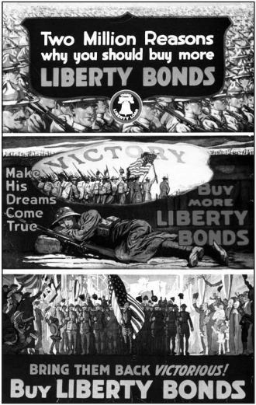**Regents Review: WWI and the Red Scare**

1) The Red Scare, the growth of the Ku Klux Klan, and the murder convictions of

Sacco and Vanzetti were influenced by

1- the rise of organized crime

2- the passage of immigration quota acts

3- a distrust of foreigners

4- an effort to stop fascism

2) This poster was used during the administration of President Woodrow Wilson to

1- convince men to enlist in the military services

2- help finance the war effort

3- support membership in the League of Nations

4- emphasize the goals of the Fourteen Points

3) The United States refused to ratify the Treaty of Versailles after World War I because many senators believed

1- President Woodrow Wilson was too ill to sign

2- most Americans had sympathized with Germany during the war

3- the treaty would not require reparations from Germany

4- the League of Nations could draw the United States into future wars

4) Which factor was the basis of the United States Senate’s opposition to the League of Nations after World War I?

1- rejection by President Woodrow Wilson of internationalism

2- fear of becoming involved in another European war

3- high financial cost of membership

4- concern over communist control of international organizations

5) After World War I, one way in which the Red Scare, the passing of the Quota Acts, and the growth of the Ku Klux Klan were similar in that they all

1- exploited fears about people who were considered un-American

2- encouraged the assimilation of new immigrants into American society

3- supported the goals of the suffrage movement

4- exhibited prejudice against African Americans

6) During World War I, what was President Woodrow Wilson’s purpose ni outlining the Fourteen Points?

1- asking congress for additional funding for the war effort

2- suggesting a peace plan to prevent future wars

3- proposing war crimes trials for leaders of enemy nations

4- calling for military alliances against aggressor nations

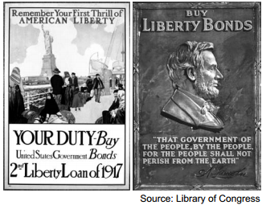

7) The United States government published these World War I posters to encourage Americans to

1- increase military enlistments

2- reduce the use of consumer goods

3- invest in the war effort

4- conserve scarce resources for the military

8)   
 **“Radical Immigrants Deported”  
“Bombs Explode on Wall Street”  
“Palmer Raids Criticized by Congress”**

These post- World War I headlines are most closely associated with the

1- Volstead Act

2- Ku Klux Klan

3- Scopes trial

4- Red Scare

9)Which event most influenced President Woodrow Wilson’s decision to enter World War I?

1- defeat of Russia by Germany

2- assassination of Archduke Franz Ferdinand

3- raids by Mexico on the southwestern United States

4- renewal of unrestricted submarine warfare by Germany

10) What was one effect of the Bolshevik Revolution (October 1917) on the United States?

1- Nativism increased, leading to the Red Scare.

2- Federal courts banned anti-immigrant groups.

3- The Allied powers needed fewer United States troops.

4- Immigration laws were changed to allow refugees from Russia.

**Regents Review: 1920’s**

1) How are the messages of Langston Hughes, Sinclair Lewis, and John Steinbeck similar?

(1) Politics and art don’t go together.

(2) The best literature is about the wealthy.

(3) Literature often reflects the times in which it is created.

(4) Traditional American themes are the most popular.

2) In the United States, the decade of the 1920’s was characterized by

(1) a willingness to encourage immigration to the United States

(2) increased consumer borrowing and spending

(3) major reforms in national labor legislation

(4) the active involvement of the United States in European affairs

3) Which group of Americans didn’t experience the economic prosperity of the 1920s?

(1) farmers (2) astronauts (3) consumers (4) manufacturers

4) The failure of national Prohibition led to a public awareness that

(1) crime rates decline when the sale of alcoholic beverages is banned

(2) economic prosperity inhibits social conformity

(3) unpopular laws are difficult to enforce

(4) people wanted to get turnt up

5) Which condition increased the negative effects of the Great Depression?

(1) Factories had to decrease production because of low demand.

(2) Low levels of unemployment created labor shortages.

(3) The Federal Government raised taxes repeatedly.

(4) The demand for imported products increased.

6) Which combination of factors contributed most to the start of the Great Depression of the 1930’s?

(1) high taxes and overspending on social welfare programs

(2) immigration restrictions and a lack of skilled workers

(3) “Those goobacks terk err jerbs!”

(4) overproduction and the excessive use of credit

7) A result of the Harlem Renaissance of the 1920s was the

(1) restoration of buildings such as the original shake shack

(2) increased recognition of African-American writers and musicians

(3) end of racial segregation laws in New York State

(4) appointment of several African Americans as presidential advisors

8) “I, Too, Sing America”

I, too, sing America.

I am the darker brother.

They send me to eat in the kitchen

When company comes,

But I laugh,

And eat well,

And grow strong.

Tomorrow,

I’ll sit at the table

When company comes.

Nobody’ll dare

Say to me,

“Eat in the kitchen,”

Then.

Besides,

They’ll see how beautiful I am

And be ashamed—

I, too, am America.

— Langston Hughes, 1926

This poem was from the

(1) Mayflower Compact

(2) Progressive Era

(3) Prohibition movement

(4) Harlem Renaissance

9) Which event represents nativism during the 1920s?

(1) trial of John Scopes for teaching evolution

(2) Charles Lindbergh’s solo trans-galactic flight

(3) rise in popularity of spectator sports

(4) adoption of a quota system to limit immigration

10) A major goal of the immigration acts of the 1920s was to

1) prohibit immigration from only Antarctica

2) guarantee equal numbers of immigrants from all nations

3) favor wealthy and well-educated immigrants

4) use quotas to limit immigration from southern and eastern Europe

**Regents Review: The Great Depression and the New Deal**

1. What was a basic cause of the Great Depression of the 1930s?

(1) Too many antitrust laws were passed.

(2) Tariffs on foreign manufactured goods were reduced.

(3) The distribution of income was unequal.

(4) Immigration was limited.

2.What was one feature of the United States economy during the 1920s that contributed to the Great Depression?

(1) increase in federal regulation

(2) expansion of easy credit

(3) growth of the trade deficit

(4) influence of foreign corporations

Base your answer to question 3 on the chart below and on your knowledge of social studies.

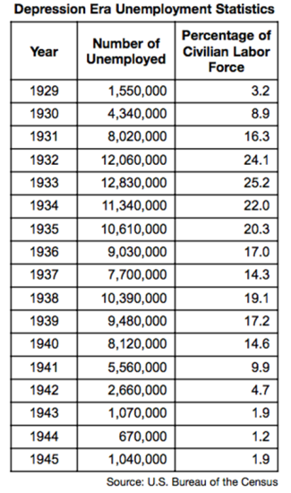

3. Which conclusion is most clearly supported by the information in the chart?

(1) President Herbert Hoover’s economic policies expanded job opportunities.

(2) The United States unemployment rate reached its highest level in 1938.

(3) President Franklin D. Roosevelt’s New Deal programs failed to address the unemployment crisis.

(4) World War II ended the high unemployment rates of the Great Depression.

4. As part of the New Deal, the Securities and Exchange Commission (SEC) and the Federal Deposit Insurance Corporation (FDIC) were created to

(1) allow for a quick recovery of stock prices

(2) provide direct loans to businesses

(3) protect individual investors from stock fraud and bank failure

(4) allow banks and companies to invest in the stock market

Base your answer to question 5 on the cartoon below and your knowledge of social studies.

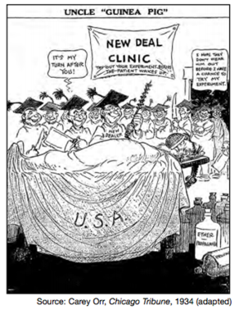

5. Which statement most accurately expresses the viewpoint of the cartoonist?

(1) New Deal programs are endangering the country

(2) Most Americans support New Deal programs

(3) Supreme Court decisions are overturning New Deal programs

(4) New Deal programs emphasize health care reforms

6. The New Deal reform that helped labor unions win the right to represent workers was the

(1) creation of Social Security

(2) formation of the Securities and Exchange Commission

(3) passage of the National Labor Relations (Wagner) Act

(4) establishment of unemployment insurance

Base your answers to questions 7 and 8 on the song lyrics below and on your knowledge of social studies.

Dust Storm Disaster

On the 14th day of April of 1935,

There struck the worst of dust storms that ever filled the sky.

You could see that dust storm comin’, the cloud looked deathlike black,

And through our mighty nation, it left a dreadful track.…

The storm took place at sundown, it lasted through the night,

When we looked out next morning, we saw a terrible sight.

We saw outside our window where wheat fields they had grown

Was now a rippling ocean of dust the wind had blown.

It covered up our fences, it covered up our barns,

It covered up our tractors in the wild and dusty storm.

We loaded our jalopies and piled our families in,

We rattled down that highway to never come back again.

— Woody Guthrie

7. Which region of the United States was most directly affected by the situation described in this song?

(1) Southeast (3) Great Plains

(2) Great Lakes (4) Pacific Northwest

8. These song lyrics were written about people who became

(1) sharecroppers in the South

(2) migrant farm workers on the West Coast

(3) fishermen in New England

9. What was the goal of President Franklin D. Roosevelt’s plan to add more justices to the

Supreme Court?

(1) to help the Supreme Court implement its decisions

(2) to limit judicial opposition to New Deal programs

(3) to convince Congress to enact new economic laws

(4) to replace the Chief Justice of the Supreme Court

Base your answer to question 10 on the maps below and on your knowledge of social studies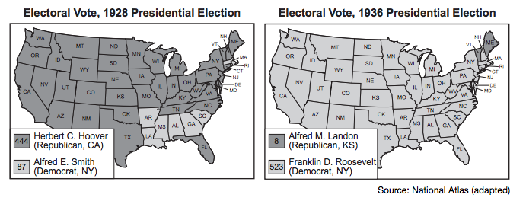

10. Which conclusion is most clearly supported by the information provided by these maps?

(1) The Great Depression altered American political preferences.

(2) The Democratic Party lost support in the Northeast between the two elections.

(3) Most voters believed in traditional approaches to economic problems.

(4) The Republican Party remained strong in the deep South.

**World War II**

1. A major cause of the growth of state and Federal highway systems after World War II was the

1. increased use of mass transit systems
2. growing prosperity of inner-city areas
3. rapid development of suburbs
4. return of city dwellers to farm areas

2. During World War II, women and minorities made economic gains mainly because

1. a shortage of traditional labor created new opportunities in the workplace
2. more educational opportunities increased the number of skilled workers in these groups
3. labor unions successfully demanded equal opportunities for these groups
4. new civil rights legislation forced businesses to change their hiring practices

3. A major cause of the internment of Japanese Americans during World War II was

1. national segregation policies
2. immigration quotas
3. racial prejudice
4. economic depression

4. In the early 1940’s, the "destroyers-for-military-bases deal" with Great Britain and the Lend-Lease Act were evidence that the United States

1. recognized that its policy of neutrality conflicted with its self-interest
2. followed its policy of neutrality more strictly as World War II progressed in Europe
3. believed that the Allied policy of appeasement would succeed
4. wanted to honor the military commitments it had made just after World War I

5. A violation of civil rights that occurred in the United States during World War II was the

1. arrests made as a result of the Palmer raids
2. passage of an open immi-gration law
3. internment of Japanese Americans
4. forced removal of Native American Indians from their reservations

6. The Lend-Lease Act and the Destroyers-for-Bases deal were adopted prior to World War II primarily because these actions would

1. help Allied nations without the United States entering the war
2. stop the spread of communism
3. convince the American people that war was necessary
4. create jobs to end the Great Depression

7. Which statement about Japanese Americans interned during World War II is most accurate?

1. Many were forced to return to Japan at the conclusion of the war.
2. No Japanese Americans were allowed to serve in the United States armed services during the war.
3. Most were released after signing a loyalty oath
4. Many lost their homes and businesses

8. President Harry Truman’s decision to use atomic bombs against Japan was primarily based on his belief that

1. an invasion of Japan would result in excessive casualties
2. Germany would refuse to surrender in Europe
3. an alliance was developing between Japan and the Soviet Union
4. Japan was in the process of developing its own atomic weapons

9. Which action best illustrates the policy of isolationism followed by the United States before it entered World War II?

1. signing of a collective security pact with Latin American nations
2. passage of neutrality legislation forbidding arms sales to warring nations
3. embargo on the sale of gasoline and steel to Japan
4. President Franklin D. Roosevelt’s exchange of American destroyers for British naval and air bases

10. President Harry Truman justified using atomic bombs on Japan in 1945 on the grounds that the

1. world was ready for a demonstration of nuclear power
2. Axis powers deserved total destruction
3. early ending of the war would save many lives
4. American public demanded that the bombs be use

**Cold War and 1950’s**

1. McCarthyism in the 1950s is most closely associated with
   1. Claims that communists had infiltrated the federal government
   2. Efforts to prevent pro-communist governments in Latin America
   3. Formation of the Warsaw Pact
   4. Passage of the Interstate Highway Act
2. A similarity between the Red Scare of the 1920’s and McCarthyism in the 1950’s was that during each period
3. thousands of American citizens were expelled from the United States
4. the Communist Party gained many members in the United States
5. many government employees were convicted of giving secrets to the Soviet Union
6. the civil liberties of American citizens were threatened
7. Which situation resulted from Senator Joseph McCarthy’s search for Communists within the United States during the 1950’s?
8. Thousands of American citizens who believed in communism were either jailed or deported.
9. The reputations of many people were ruined by false accusations of disloyalty
10. Many high-ranking government officials were exposed as spies of the Soviet Union.
11. Organized groups of Communists began a wave of violent political terrorism
12. The successful launching of Sputnik by the Soviet Union in 1957 signaled the beginning of
13. American fears that the Soviets had achieved technological superiority
14. the Cold War with the United States
15. Soviet aggression in Afghanistan and China
16. disarmament discussions between the superpowers
17. "Those of us who shout the loudest about Americanism in making character assassinations are all too frequently those who, by our own words and acts, ignore some of the basic principles of Americanism."

-Senator Margaret Chase Smith, 1950

This criticism of Senator Joseph McCarthy and his supporters suggests that

1. Senator McCarthy did not do enough to protect the nation from a Communist conspiracy
2. the tactics of Senator McCarthy were necessary to protect the basic principles of democracy
3. free speech must be limited in times of national crisis
4. Senator McCarthy was a greater threat to the nation than Communist sympathizers were
5. In a farewell message to the American public, President Dwight D. Eisenhower warned of the growth of the "military-industrial complex." This term refers to the
6. influence of defense contractors on Congress
7. threat from the Soviet Army
8. internal danger from Communist spies
9. economy’s dependence on oil imported from the Middle East
10. “Sputnik Launch Propels Soviets Ahead in Space Race” In 1957, the United States government responded to the event described in this headline by
11. reducing military spending
12. building a joint space station with the Soviet Union
13. constructing President Ronald Reagan’s “Star Wars” defense system
14. providing funds to improve the educational system in the United States
15. Who led a “witch hunt” for Communist spies in the United States government during the early 1950s?
16. Supreme Court Justice Earl Warren
17. President Dwight Eisenhower
18. Senator Joseph McCarthy
19. Secretary of State Dean Acheson
20. The baby boom primarily resulted from the
21. economic prosperity of the 1920s
22. Great Depression of the 1930s
23. delay in marriages during World War II
24. counterculture movement of the 1960s
25. The rapid growth in personal income in the decade after World War II contributed to
26. a decrease in the birthrate
27. a major economic depression
28. expansion of the middle class
29. shortages in the supply of luxury goods

**Cold War Foreign Policy Multiple Choice Questions**

1. The Truman Doctrine and the Marshall Plan represented attempts by the United States to deal with the
2. National debt
3. Spread of communism
4. President political oppression
5. Arms race

1. “An attack on one shall be considered an attack on all.” This statement summarizes the foreign policy known a
2. colonialism
3. nonalignment
4. appeasement
5. collective security

1. Shortly after World War II, the cold war developed mainly as a result of the
2. United States refusal to send economic aid to European nations
3. Soviet domination of Eastern Europe
4. competition between the superpowers to explore outer space
5. continuation of the pre-World War II balance of power

1. Which development led to the other three?
2. The United States government increased funding for science and math
3. The Soviet Union launched the Sputnik satellite.
4. A joint Soviet-American space mission was announced.
5. President John F. Kennedy set the goal of landing a man on the Moon.
6. “Batista Driven from Power” “Bay of Pigs Invasion Fails” “U-2 Planes Reveal Soviet Missiles” These headlines refer to the relationship between the United States and
7. Canada
8. Cuba
9. Mexico
10. Panama
11. The Korean War and the Persian Gulf War were similar in that both
12. represented United Nations efforts to assist nations in repelling aggressors
13. involved unilateral military action by the United States
14. were military defeats for the United Nations
15. brought about lasting solutions to problems in each region

1. A major long-term effect of the Vietnam War has been
2. an end to communist governments in Asia
3. a change in United States foreign policy from containment to imperialism
4. a reluctance to commit United States troops for extended military action abroad
5. a continued boycott of trade with Asia

1. The primary purpose of the War Powers Act (1973) is to
2. limit Presidential power to send troops into combat
3. allow for a quicker response to a military attack
4. assure adequate defense of the Western Hemisphere
5. stop the use of troops for nonmilitary purposes

1. The Peace Corps was established by President John F. Kennedy in an effort to provide
2. support to developing nations of the world
3. job training for the unemployed
4. markets for consumer goods
5. teachers for inner-city areas

1. The primary purpose of President Richard Nixon’s policy of détente was to
2. expand United States military involvement in Southeast Asia
3. assure an adequate supply of oil from the Middle East
4. ease tensions between the United States and the Soviet Union
5. maintain a favorable balance of trade with China

**1960’s & The Great Society**

* 1. Which action is the best example of the use of civil disobedience?
  2. passing the Voting Rights Act of 1965
  3. lobbying Congress to eliminate the poll tax
  4. attending a political rally in Iowa
  5. conducting sit-ins at restaurants in the South
  6. Base your answer to question 2 on the song lyrics below and on your knowledge of social studies.

… Come mothers and fathers

Throughout the land

And don’t criticize

What you can’t understand

Your sons and your daughters

Are beyond your command

Your old road is

Rapidly agin’.

Please get out of the new one

If you can’t lend your hand

For the times they are a-changin’…

Bob Dylan, ‘The Times They Are A-Changin’,” 1963

Which concern of the 2960s is being commented on by the author of these lyrics?

1. rural poverty
2. adult illiteracy
3. environmental protection
4. the generation gap
   1. A major goal of the Great Society programs begun under President Lyndon B. Johnson was to
   2. stimulate oil production in the United States
   3. provide tax concessions to manufacturers
   4. reduce poverty in the nation
   5. increase the size of the armed forces
   6. The Gulf of Tonkin Resolution (1964) provided congressional support for
5. withdrawing from the United Nations
6. expanding the Alliance for Progress
7. escalating military action in Vietnam
8. reestablishing trade with Cuba
   1. 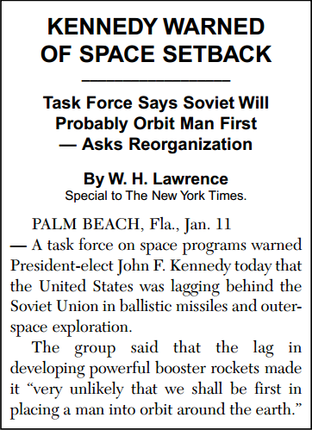Base your answer to question 5 on the accompanying newspaper article and on your knowledge of social studies.

President Kennedy responded to warnings like this by

1. promising to explore Mars and other nearby

planets

1. asking Congress to fund the Hubble telescope
2. pledging to put a man on the Moon within a

decade

1. joining the Soviet Union in building a space

station

Source: *The New York Times,*

January 12, 1961 (adapted)

* 1. The baby boom in the 1950s and 1960s had
  2. rebirth of urban districts
  3. decreased use of child labor in factories
  4. recruitment for the armed forces
  5. construction of housing and schools
  6. One way the United States government reacted to the Soviet launching of Sputnik in 1957 was by

1. establishing a naval blockade of Cuba
2. urging more Americans to buy war bonds
3. starting the Strategic Arms Limitation Talks

(SALT)

1. increasing federal spending on math and

science education

* 1. • Mapp v. Ohio, 1961

• Gideon v. Wainwright, 1963

• Miranda v. Arizona, 1966

These three Supreme Court decisions are similar

in that each ruling

1. expanded the rights of the accused
2. reduced presidential powers
3. shifted more power to the states
4. limited campaign contributions
   1. Base your answer to question 9 on the passage below and on your knowledge of social studies.

… We will stay because in Asia and around the world are countries whose independence rests, in large measure, on confidence in America’s word and in America’s protection. To yield to force in Vietnam would weaken that confidence, would undermine the independence of many lands, and would whet the appetite of aggression. We would

have to fight in one land, and then we would have to fight in another—or abandon much of Asia to the domination of Communists.…

— President Lyndon B. Johnson,

State of the Union Address, January 12, 1966

Which idea is best described in this passage?

(1) appeasement

(2) isolationism

(3) domino theory

(4) neutrality

* 1. A result of the publication of Rachel Carson’s *Silent Spring* was that the
  2. Americans with Disabilities Act was passed
  3. 1964 Civil Rights Act was passed
  4. modern environment movement gained support
  5. consumer protection movement began

**Civil Rights Movement**

… It is important that the reasons for my action be understood by all our citizens. As you know, the Supreme Court of the United States has decided that separate public educational facilities for the races are inherently unequal and therefore compulsory school segregation laws are unconstitutional.…   
— President Dwight D. Eisenhower, September 24, 1957

1. Which Supreme Court case is referred to in this quotation?  
(1) Dred Scott v. Sanford  
(2) Brown v. Board of Education of Topeka  
(3) Heart of Atlanta Motel v. United States  
(4) Tinker v. Des Moines School District

2. Which action is the best example of the use of civil disobedience?   
(1) passing the Voting Rights Act of 1965  
(2) lobbying Congress to eliminate the poll tax  
(3) attending a political rally in Iowa  
(4) conducting sit-ins at restaurants in the South

3. Which action did President Dwight D. Eisenhower take to enforce this Supreme Court decision?  
(1) ordering the closing of Central High School in Little Rock, Arkansas  
(2) sending United States Army troops to enforce school integration  
(3) proposing legislation in support of school Segregation  
(4) transferring white students to a new public high school

4. A primary reason for the passage of the 14th amendment in 1868 was to  
(1) prohibit the secession of states   
(2) uphold the legality of the Black Codes  
(3) continue the presidential plan for Reconstruction  
(4) guarantee citizenship rights to the newly freed slaves

5. Which factor contributed most to the repeal of national Prohibition in 1933?  
(1) the inability of government to enforce the law  
(2) an improvement in the economy  
(3) a decline in organized crime   
(4) the start of World War II

6. The Supreme Court decision in Plessy v. Ferguson (1896) affected African Americans by  
(1) granting voting rights  
(2) expanding civil rights  
(3) upholding racial segregation  
(4) guaranteeing equal wages

7. In New Jersey v. T.L.O. (1985) and Vernonia School District v. Acton (1995), the United States Supreme Court ruled that  
(1) student rights may be limited in school  
(2) school locker searches are unconstitutional  
(3) public schools have the right to promote school prayer  
(4) schools must obtain a court order to implement drug testing

8. The “clear and present danger” principle stated by the Supreme Court in Schenck v. United States (1919) had the effect of  
(1) prohibiting the president from implementing a military draft  
(2) preventing the wartime internment of citizens  
(3) restricting the formation of defense alliances  
(4) limiting freedom of speech during wartime

9. One way in which the feminist movement of the late 1960s and early 1970s is similar to the civil rights movement of the 1950s and 1960s is that both  
(1) used public demonstrations and protests to draw attention to their goals  
(2) opposed Supreme Court decisions expanding the rights of the accused  
(3) refused support from churches and religious leaders  
(4) focused on securing equal access to housing

An African American member of the armed forces from New York City examines the “Colored Waiting Room” sign at Terminal Station in Atlanta, Georgia, 1956  
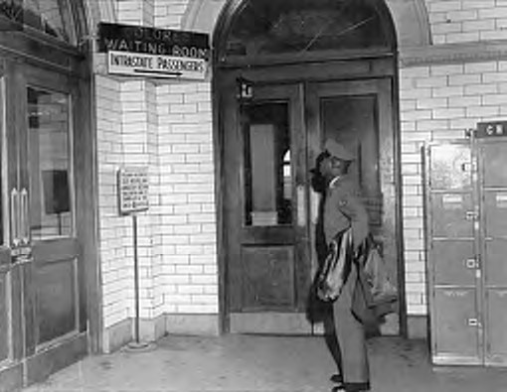  
10. Which circumstance is most clearly illustrated by this photograph?  
(1) equality in accommodations experienced by African Americans  
(2) discrimination while serving one’s country  
(3) civil disobedience being used to protest racial segregation  
(4) social changes in New York City after World War II

**Regents Review: Nixon and Watergate**

1. The Strategic Arms Limitation Treaty (SALT), signed by President Richard Nixon with the Soviet Union, was an effort to advance the foreign policy of
   1. Détente
   2. Imperialism
   3. Brinkmanship
   4. Globalization
2. The terms *Teapot Dome*, *Watergate*, and *Iran-Contra* are most closely associated with
   1. Domestic policies
   2. Presidential scandals
   3. Federal court decisions
   4. Failed reform movements
3. Which principle was most weakened as a result of the Watergate controversy?
   1. Congressional immunity
   2. Executive privilege
   3. Judicial review
   4. States’ Rights
4. The main significance of the Watergate affair was that it
   1. Led to the impeachment and conviction of President Richard Nixon
   2. Showed that the laws of the United States are superior to the actions of a President
   3. Was the first time a President had disagreed with Congress
   4. Proved that Presidential powers are unlimited
5. What was a lasting effect of the Watergate scandal under President Richard Nixon?
   1. The system of checks and balances was weakened
   2. The scope of executive privilege was broadened
   3. Trust in elected official was undermined
   4. Presidential responsiveness to public opinion was lessened
6. President Richard Nixon supported the policy of détente as a way to
   1. Reduce tensions between the United States and the Soviet Union
   2. Introduce democratic elections to communist nations
   3. Encourage satellite nations to break their ties with the Soviet Union
   4. Undermine Soviet influence among nonaligned countries in Africa and Asia
7. President Richard Nixon’s visit to the People’s Republic of China in 1972 was significant because it
   1. Convinced the Chinese to abandon communism
   2. Brought about the unification of Taiwan and Communist China
   3. Reduced tensions between the United States and Communist China
   4. Decreased United States dependence on Chinese exports
8. Base your answer to question 8 on the accompanying magazine covers and on your knowledge of social studies.

What was a result of the events reflected in these magazine covers?

* 1. Many Americans lost trust in their government.
  2. The Supreme Court ruled in favor of the president’s actions.
  3. Freedom of the press was limited.
  4. President Richard Nixon was defeated in his bid for reelection.



1. Base your answer to question 9 on the newspaper headlines and on your knowledge of social studies.

Which constitutional provision is most clearly illustrated by these headlines?

* 1. Presidential power
  2. Qualifications to be president
  3. Presidential succession
  4. Advice and consent of the Senate



1. Base your answer to question 10 on the cartoon and on your knowledge of social studies.

Which statement best describes the point of view of the cartoonist?

* 1. The press is responsible for misleading the public about the Nixon administration.
  2. Most Americans continue to support the policies of the Nixon administration.
  3. The articles of impeachment against President Richard Nixon are unjustified.
  4. President Richard Nixon is directly involved in the Watergate cover up.

**Regents Review: Ford and Carter Presidencies**

1. United States participation in the Washington Conference (1921), in the Kellogg-Briand Pact (1928), and in the SALT talks of the 1970’s is evidence that the United States

1.) has followed a free trade policy for most of the 20th century

2.) relies on military alliances for defense against aggression

3.) has been willing to cooperate with other nations to reduce world tensions

4.) believes that cultural exchange programs are a way to promote international understanding

2. Which statement is most accurate about the economy of the United States during the 1970’s and early 1980’s?

1.) The increased cost of imported oil hurt economic growth.

2.) The Federal budget was balanced.

3.) Inflation declined sharply throughout these years .

4.) The number of jobs in farming increased while service jobs decreased.

3. The Camp David accords negotiated during President Jimmy Carter’s administration were an attempt to

1.) decrease United States control of the Panama Canal

2.) encourage the use of solar and other nonpolluting energy sources

3.) end inflationary oil prices

4.) establish peace in the Middle East

4. The Washington Naval Conference of 1921-22 and the SALT talks of the 1970’s between the United States and the Soviet Union both reflect the belief that

1.) civil wars within nations can create international hostilities

2.) escalating military buildups are one of the causes of war

3.) cultural exchange programs can reduce world tensions

4.) rivalry between nations over the control of natural resources is the major cause of conflict

5. "President Nixon Plans Trip to China To Meet with Chairman Mao"

"President Carter Signs New Panama Canal Treaty"

"President Clinton Concludes Trade Agreement with Japan"

Each headline illustrates an action of a President fulfilling his role as

1.) head of his political party

2.) Commander in Chief

3.) chief diplomat

4.) chief legislator

6. Which factor contributed most to inflation in the United States during the 1970s?

1.) high tariffs

2.) oil embargoes

3.) tax increases

4.) high unemployment

7. “. . . Our decision about energy will test the character of the American people and the ability of the President and the Congress to govern. This difficult effort will be the ‘moral equivalent of war’— except that we will be uniting our efforts to build and not destroy. . . .” — President Jimmy Carter Address to the Nation, April 18, 1977

President Carter put these ideas into practice by

1.) halting construction of nuclear power plants

2.) increasing imports of foreign oil

3.) urging the development of alternative fuel sources

4.) imposing a price freeze on all petroleum products

8. Which foreign policy agreement had the most direct influence on the Middle East?

1.) Kellogg-Briand Pact

2.) Yalta Conference declaration

3.) SALT I Treaty

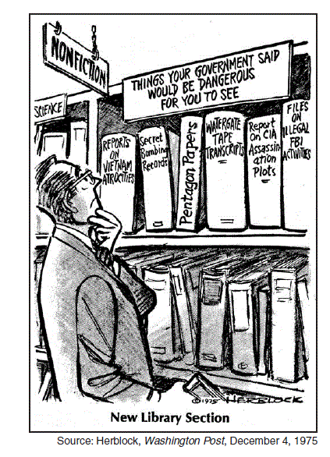4.) Camp David Accords

9. Which statement most accurately describes the main idea of this 1975 cartoon?

1.) The press should not publish materials that damage the reputation of public officials.

2.) The government is improperly hiding information from the public.

3.) Government should restrict the publication of sensitive materials.

4.) Libraries are making too many government reports open to the public.

10. President Ford's foreign policy included support for all of the following EXCEPT?

1. the SALT II agreement
2. the Helsinki agreement on European boundaries
3. the continued rapprochement with China after the death of Mao Zedong
4. the abandonment of United States mediation efforts in the Middle East.

**Reagan Era and New Federalism**

1. The terms Teapot Dome, Water Gate and Iran-Contra are most closely associated with

1. Domestic policies
2. Presidential scandals
3. Federal courts decisions
4. Failed reform movements

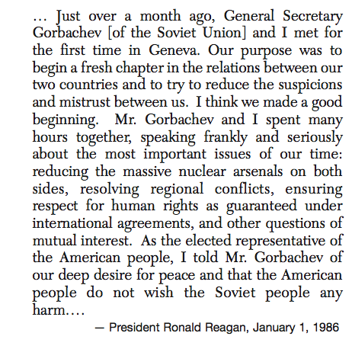

2. One major issue that dominated United States- Soviet relations at this time was the

1. War in southeast Asia
2. Use of apartheid in South Africa
3. Danger of nuclear destruction
4. Threat from al Qaeda in the middle east

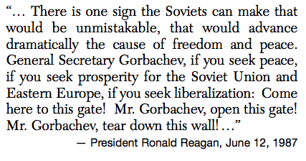

3. President Reagan was calling for which for the end of the

1. Nuclear arms race
2. Soviet invasion of Afghanistan
3. Division of Berlin, Germany
4. Warsaw Pact

* Theodore Roosevelt mediates adoption of the Treaty of Portsmouth
* Richard Nixon visits china
* Bill Clinton supports peace accords in Northern Ireland

4. These actions are examples if various presidents acting as

1. Chief diplomat
2. Head of party
3. Chief legislator
4. Commander in chief

5. President Ronald Reagan and President George W Bush shared the belief that tax cuts would result in

1. A reduction in exports
2. The growth of the economy
3. An increase in the federal bureaucracy
4. A rise in unemployment

6. Which action did President Reagan support to achieve economic growth?

1. Lowering taxes on corporations and individuals
2. Increasing spending on social welfare programs
3. Cutting defense budgets
4. Increasing the regulation of industry

7. President Ronald Reagan’s supply-side economic system policy was successful in

1. Increasing government spending on social programs
2. Lowering tax rates on personal and business income
3. Reducing defense spending
4. Enforcing stricter environmental regulations

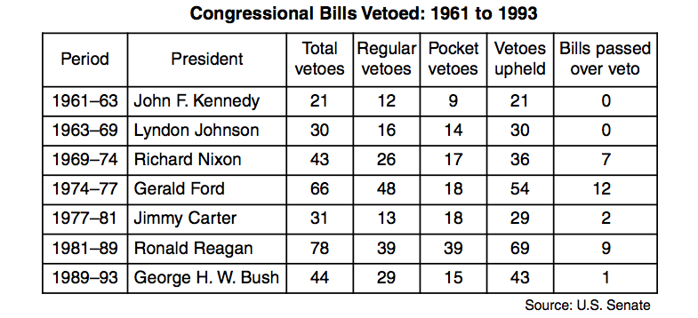

8. Which statement is accurate about congressional bills vetoed between 1961 and 1993?

A. Congress was usually able to override a presidential veto

B. Pocket vetoes were used more often than regular vetoes

C. The majority of presidential vetoes were upheld

D. The use of the veto increased steadily between 1961 and 1993

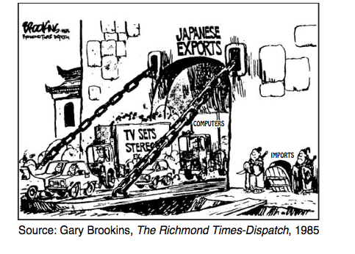

9. What is the main topic of this 1985 cartoon?

A. Quality of Japanese products

B. Imbalance in Japanese-United States trade

C. Outsourcing of American jobs to Japan

D. Relocation of American companies to Japan

10. President Ronald Reagan used the concept of supply-side economics when he proposed

A. Reducing income taxes to stimulate growth

B. Providing direct payments to people living in poverty

C. Creating government jobs to keep people working

D. Increasing regulations on business to promote competition

Regents Review: Landmark Supreme Court Cases

1. Which idea is illustrated by the Supreme Court cases *Schenck v. United States* and *Korematsu v. United States*?
2. The free speech rights of Communists have often been violated.
3. During wartime, limitations on civil rights have been upheld by judicial action.
4. The rights of protestors have been preserved even in times of national stress.
5. Economic interests of foreign nations are frequently upheld in United States courts.

2. The *Dred Scott* decision on the issue of slavery upheld the Southern viewpoint that

1. the power of the Supreme Court does not extend to cases of race
2. Congress could not pass a law depriving territorial residents of their property
3. a national vote should be held to decide the legality of slavery
4. the economic well-being of the western states depended on slave labor

3. The decisions of the United States Supreme Court in *Miranda v. Arizona*, *Gideon v. Wainwright*, and *Escobedo v. Illinois* all advanced the

1. voting rights of minorities
2. guarantees of free speech and press
3. principle of separation of church and state
4. rights of accused persons

4. An immediate result of the Supreme Court decision in *Schechter Poultry Corporation v. United States* (1935) and *United States v. Butler* (1936) was that

1. some aspects of the New Deal were declared unconstitutional
2. State governments took over relief agencies
3. Congress was forced to abandon efforts to improve the economy
4. the constitutional authority of the President was greatly expanded

5. The significance of the Supreme Court case *Marbury v. Madison* is that the decision

1. advanced civil rights for minorities
2. upheld the constitutionality of a national bank
3. limited Presidential control of foreign policy
4. established the power of judicial review

6. "Separate educational facilities are inherently unequal."-*Brown v. Board of Education*

The effect of this Supreme Court ruling was to

1. establish affirmative action programs in higher education
2. require the integration of public schools
3. desegregate the armed forces and the military academies
4. force states to spend an equal amount on each public school student

7. What was the result of many of the Supreme Court decisions made under Chief Justice John Marshall between 1801 and 1835?

1. The system of slavery was weakened.
2. The federal government was strengthened.
3. The rights of workers were supported.
4. Antitrust laws were upheld.

8. The Supreme Court cases of Tinker v. Des Moines and New Jersey v. TLO involved the issue of

1. freedom of the press
2. the rights of students in school
3. freedom of religion
4. the rights of prison inmates

9. In Plessy v. Ferguson (1896), the Supreme Court ruled that

1. states may not secede from the Union
2. racial segregation was constitutional
3. slaves are property and may not be taken from their owners
4. all western territories should be open to slavery

10. The Supreme Court decision in Roe v. Wade (1973) was based on the constitutional principle of

1. protection of property rights
2. freedom of speech
3. right to privacy
4. freedom of religion

**Cross-topical regents**

1. Which heading best completes the partial outline below?

________________________

A. Trade restrictions

B. Laissez-faire

C. Trickle-down theory

D. Wage and price controls

1. Social reforms

2. Constitutional amendments

3. Economic policies

4. Religious beliefs

1. Changes in policies during the administrations of both President Woodrow Wilson and President FDR demonstrate that
2. War can influence domestic reform programs
3. Public opinion is usually opposed to deficit spending
4. Presidents often lose power during wartime
5. United States territorial expansion results in economic growth

1. The terms Teapot Dome, Watergate, and Iran-Contra are most closely associated with
2. Domestic policies
3. Presidential scandals
4. Federal court decisions
5. Failed reform movements

4. One way in which the New Deal and Great Society are similar is that both programs were based on the belief that

1. Volunteer organizations should take over federal relief efforts

2. Government should impose fewer regulations in business

3. States should pay a larger share of the cost of federal programs

4. The federal government should do more to help citizens in need

5. The Supreme decision in Schenk v. US (1919) and the passage of the USA Patriot Act (2001) demonstrate the principle that the federal government can

1. Guarantee citizens the right to bear arms

2. Restrict the power of the president

3. Limit individual rights in time of national emergency

4. Expand the liberties protected by the Bill of Rights

6. One way in which the Hayes-Tilden election of 1876 and the Bush-Gore election of 2000 are similar is that in each election the winner was

1. Selected by state senators

2. Elected without a majority of the popular vote

3. Aided by a third-party candidate

4. Chosen by the US Supreme Court

7. President Ronald Reagan and President George W. Bush shared the belief that tax cuts would result in

1. A reduction in exports

2. The growth of the economy

3. An increase in the federal bureaucracy

4. A rise in unemployment

8. The growing use of the automobile in the 1920s and the Interstate Highway Act of 1956 both contributed to

1. The expansion of inner cities

2. An increase in Immigration

3. The growth of suburbs

4. A resurgence in rail travel

9. Which statement best describes a concern shared by John Muir, Theodore Roosevelt, and Rachel Carson?

1. The rights of the disabled are not respected

2. Campaign finance is needed to improve government

3. The natural environment must be protected

4. The growth of the federal budget deficit is a threat to the nation

10. The League of Nations and the United Nations were both formed with the goal of

1. Preventing wars through peaceful negotiations

2. Prohibiting the development of nuclear weapons

3. Monitoring the world’s monetary systems

4. Supporting the spread of democracy

Part II: Cross topical

Q1. Which is a valid conclusion based on a study of the presidencies of Thomas Jefferson and Franklin D. Roosevelt?

1. Strong third parties develop when the two major parties ignore popular demands.
2. Presidential success depends mainly on a sympathetic Supreme Court.
3. Economic crisis can force a President to suspend basic civil liberties.
4. A President’s political program may change in the face of current needs.

Q2. The power of the Presidency has increased in the 20th century mainly because

1. Congress has granted much of its authority to the President
2. events have often required the personal diplomacy and leadership of the President
3. constitutional amendments have increased the power of the executive branch
4. Supreme Court rulings have enhanced Presidential authority

Q3. The reason for ending the importation of enslaved persons to the United States after 1807 was the

1. success of the American colonial revolution against Britain
2. rapid industrialization of the South
3. replacement of slave labor by immigrant workers from eastern Europe
4. passage of legislation that forbids the practice

Q4. One similarity between the actions of Samuel Gompers and Cesar Chavez is that both leaders

1. organized workers to strive for better conditions
2. relied on the use of force to gain minority rights
3. advocated federal regulation of railroad rates
4. worked to improve consumer product safety

Q5. One similarity in the presidential administrations of Abraham Lincoln, Franklin D. Roosevelt, and Lyndon Johnson is that each

1. maintained a foreign policy of neutrality
2. expanded the power of the presidency
3. removed Supreme Court Justices from office
4. decreased the size of the military

Q6. The Pacific [Transcontinental] Railway Act (1862) and the Interstate Highway Act (1956) are both examples of

1. federally supported internal improvement projects linking the nation
2. regional construction projects coordinated by southern and western states
3. military projects required to meet the needs of the defense industry
4. transportation legislation designed to encourage foreign trade

Q7. Mark Twain, Langston Hughes, and John Steinbeck made their most important contributions to the United States in the field of

1. music
2. politics
3. literature
4. business

Q8. One way in which the New Deal, the Fair Deal, and the Great Society are similar is that these programs

1. promoted the idea of “rugged individualism”
2. increased government commitment to the well-being of the people
3. reduced the amount of money spent on domestic programs
4. encouraged the states to take a more active role in national defense

Q9. One similarity between the laws being challenged in the United States Supreme Court cases of Plessy v. Ferguson (1896) and Korematsu v. United States (1944) is that

1. specific groups of people were being targeted based on race or ethnicity
2. state laws were declared unconstitutional
3. immigrants were relocated to prison camps
4. federal laws segregating public transportation were upheld

Q10. Which of these trials established the principle that leaders of a nation may be tried for crimes against humanity?

1. Scopes
2. Rosenberg
3. Sacco and Vanzetti
4. Nuremberg

**Current Issues**

1. Which trend has reflected the increasing pluralism in United States society in recent years?

* + - 1. a decrease in immigration from Latin America
      2. growing demands for unskilled labor
      3. new efforts by public schools to teach about ethnic heritages
      4. failure of Congress to approve appointments of women and minority groups to Federal courts

2. Raising import duties on foreign manufactured goods is an example of

1. technological competition
2. supporting free trade
3. lowering inflation
4. economic protectionism

3. Which statement about public education in the United States is most accurate?

1. The Federal Government controls but does not fund education.
2. The problems that affect other segments of American society seldom affect education.
3. Education is largely controlled and financed by state governments and local communities.
4. High school enrollments have decreased over the last 100 years.

4. The major political parties in the United States obtain most of their national campaign funds from

1. the personal fortunes of the candidates
2. state and local taxes
3. funds appropriated by Congress
4. the contributions of individuals and special-interest groups

5. The development of nuclear weapons by India and Pakistan has been criticized by the United States government because

1. India and Pakistan are allies of Russia
2. India and Pakistan have threatened to use these weapons against the United States
3. the United States insists on maintaining its nuclear capability
4. the spread of nuclear weapons threatens all humankind

6. How were the presidential elections of 1876 and 2000 similar?

1. The winner of the popular vote lost the electoral vote.
2. Third-party candidates did not affect the outcome.
3. The outcome of the election was decided by Congress.
4. The winner was decided by the Supreme Court.

7. What was a direct result of the census of 2000?

1. Personal income tax rates were changed.
2. New United States District Courts were created.
3. Seats in the House of Representatives were reapportioned.
4. The number of United States Senators was increased.

8. In the last 20 years, the use of automation in United States industry has led to

1. a shortage of consumer goods
2. increased union membership
3. the lowering of the legal minimum wage
4. increased unemployment among unskilled workers

9. The widespread use of computers has led to a national concern over

1. increased pollution of the environment
2. guarding the right to privacy
3. protection of the right to petition
4. a decline in television viewing

10. What is the main criticism of affirmative action in recent years?

1. The program has been extremely costly to the Federal Government.
2. Hiring quotas for minorities may have denied opportunities to other qualified persons.
3. Very few minority persons have been hired.
4. Most state governments have been unwilling to enforce the program.

Part II

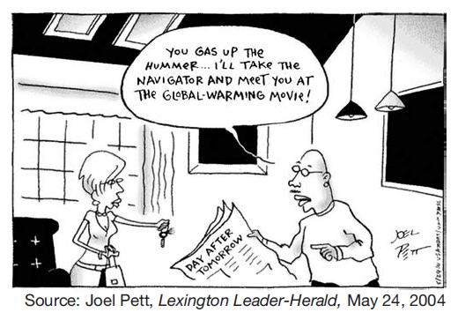

1. The main purpose of this cartoon is to point out

that

(1) global warming is a proven theory

(2) additional oil supplies must be located

(3) individuals contribute to environmental

problems

(4) prosperity depends on increased sales of

automobiles

2. Which development led to the other three?

(1) United States invasion of Afghanistan

(2) increased security at airports

(3) creation of the Department of Homeland

Security

(4) September 11, 2001 attacks on the United

States

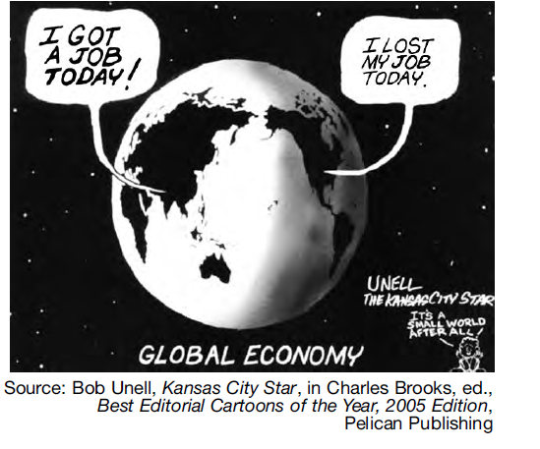

3. Which development is the topic of this cartoon?

(1) increase in trade between the United States

and Southeast Asia

(2) outsourcing of American jobs to foreign

countries

(3) abandonment of free trade agreements with

other countries

(4) payment of higher wages to overseas workers

4. The goal of current Federal Government policies toward Native Americans is to

1. make Native Americans more dependent on the Federal Government

2. give the states more control over Native American affairs

3. eliminate tribal ties and customs

4. give Native Americans more control over their own affairs

5. . As the average age of the nation’s population increases, there will be a need to

1. create more child care facilities
2. address the financing of Medicare
3. increase the number of public schools
4. reform immigration laws

6. The widespread use of computers has led to a national concern over

1. increased pollution of the environment
2. guarding the right to privacy
3. protection of the right to petition
4. a decline in television viewing

7. “Influence of Political Action Committees Continues to Rise” “Republicans and Democrats Spend over $100 Million in 2000 Presidential Election” “Senate Passes Campaign Finance Reform Act” What is the central issue of these headlines?

1. Republicans and Democrats spend equal amounts of money

2. American citizens pay high taxes to support presidential campaigns

3. Money has a strong impact on the American political process

4. Candidates spend much of their own money on political campaigns

8. The North American Free Trade Agreement (NAFTA) and the General Agreement on Trade and Tariffs (GATT) have encouraged countries to

1. participate in the global economy

2. create a uniform international currency

3. accept similar wage and price controls

4. regulate multinational corporations

9. The dispute over counting Florida voter ballots in the presidential election of 2000 was settled by

1. an order of the governor of Florida

2. an agreement between the candidates

3. a vote of the United States Senate

4. a United States Supreme Court decision

10. During the next 30 years, what will be the most likely impact of the baby boom that followed World War II?

1. More money will be spent on national defense.

2. The cost of health care will decrease.

3. Social Security will have to provide for increasing numbers of retired people.

4. The elderly will be the smallest segment of the population.

Regents Review: Geography

1. Which geographic factor most directly influenced the location of the first English settlements in North America?
   1. Rivers along the Atlantic coast
   2. Availability of flat land in the Midwest
   3. Mild climate along the Gulf coast
   4. Forests throughout the Middle Colonies
2. Which geographic factor had the greatest influence on early patterns of industrialization in the United States?
   1. scarcity of flat land on which to build factories
   2. shortages of timber and coal
   3. desire of workers to live in mild climates
   4. availability of waterpower to operate machines
3. The presence of which pair of geographic conditions discouraged the development of a plantation economy in the New England colonies?
   1. wide coastal plain and absence of good harbors
   2. rocky soil and short growing season
   3. numerous rivers and humid climate
   4. flatlands and lack of forests

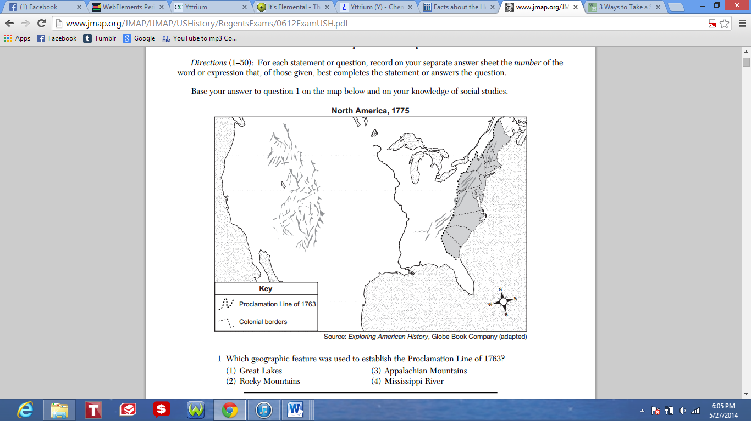

1. Which geographic feature was used to establish the Proclamation Line of 1763?
   1. Great Lakes
   2. Rocky Mountains
   3. Appalachian Mountains
   4. Mississippi River
2. What was a main reason large plantations developed in the South during the colonial period?
   1. British laws discouraged tenant farming.
   2. Cotton could only be grown in wetlands.
   3. Southern mountains led to the development of isolated, self-sufficient farms.
   4. The coastal plain in the South contained large areas of fertile soil.
3. Which city is correctly paired with the geographic feature that most directly affected its growth?
   1. New Orleans — Pacific Ocean
   2. New York City — Chesapeake Bay
   3. Chicago — Great Lakes
   4. Los Angeles — Appalachian Mountains

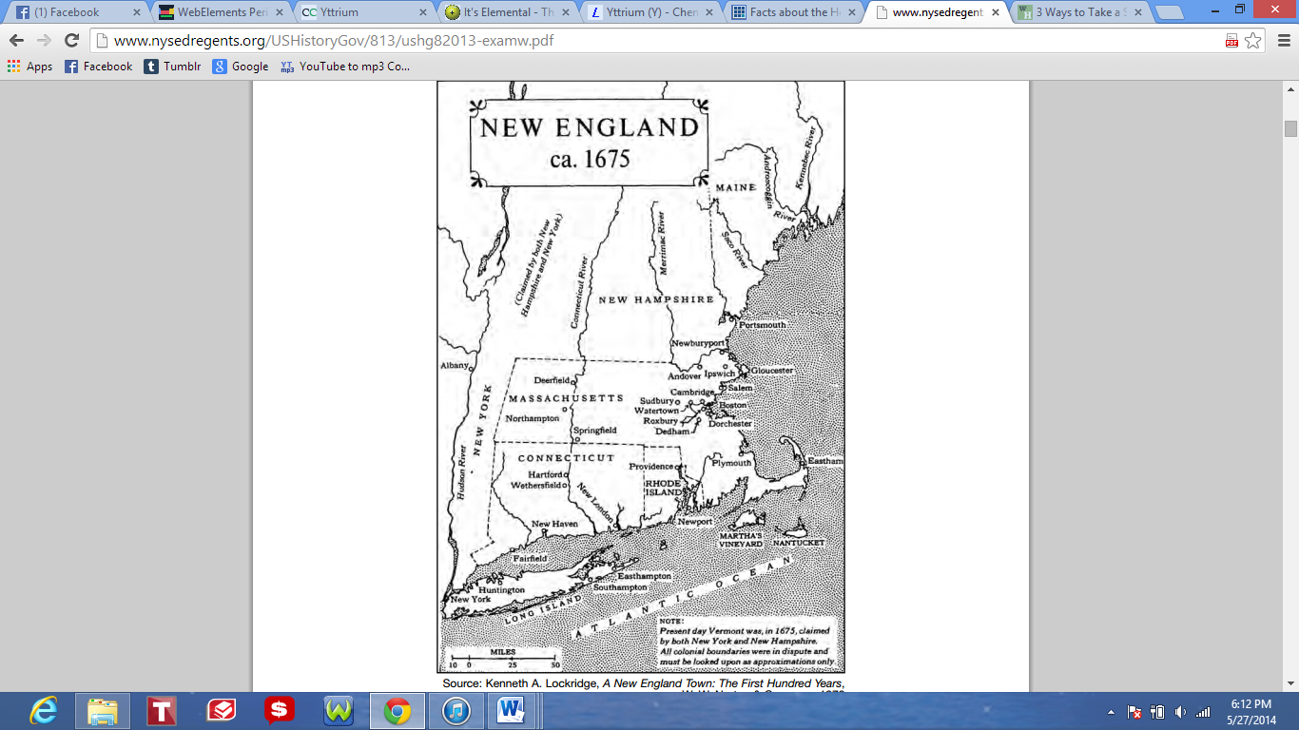

1. Based on this map, which statement about the geography of colonial New England is most accurate?
   1. New Hampshire had the highest population density.
   2. Rivers served as natural boundaries between the colonies.
   3. The first communities developed along rivers and coastlines.
   4. The Atlantic Ocean isolated the region from the rest of the colonies.
2. Which geographic feature connected the iron ore fields of the upper Midwest to the major steel centers?
   1. Great Lakes
   2. Gulf of Mexico
   3. Hudson River
   4. Tennessee River Valley
3. The original settlements in the thirteen British colonies were all located
   1. East of the Appalachian Mountains
   2. Along the Gulf Coast
   3. On the Great Plains
   4. West of the Mississippi River

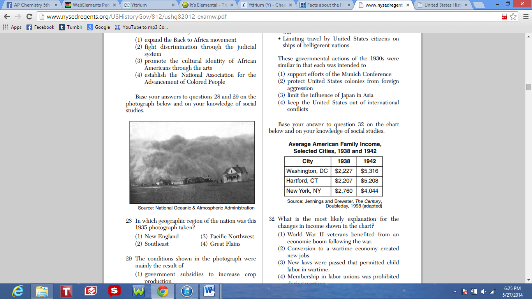

1. In which geographic region of the nation was this 1935 photograph taken?
   1. New England
   2. Southeast
   3. Pacific Northwest
   4. Great Plains