AP American History Mrs. Scherer
Name: _______________________________________ Period: __________
Unit: The Progressive Era
Here are 5 of the 7 documents you will have the day of the test. You may not use this exact piece of paper the day of the test but feel free to analyze the following using the boxes I’ve provided to help guide you. It would also be good practice to use the “sentence starters” to practice incorporating HAPP into your essay. Remember you only need to demonstrate ONE of HAPP – either show H.C. OR Audience OR Purpose OR Point of View.
Document A.

What is the Document About? | Source: Washington Post, 1907  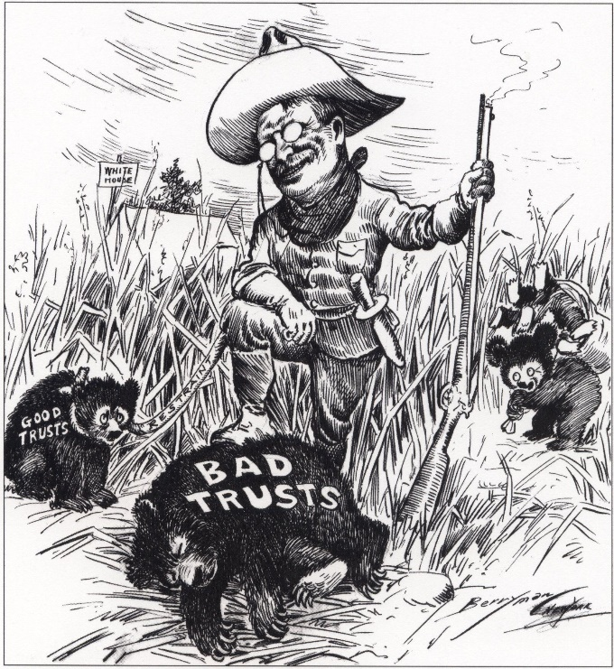  One Piece of Outside Information related to this document. | Which H.A.P.P. can I use?

Document B.

What is the Document About? | Source: The Neill-Reynolds Report, June 4, 1906  Meat scraps were also found being shoveled into receptacles from dirty floors where they were left to lie until again shoveled into barrrels or into machines for chopping. These floors, it must be noted, were in most cases damp and soggy, in the dark, ill ventilated roooms, and the employees in utter ignorance of cleanliness or danger to health, expectorated at will upon them. In a word, we saw meat shoveled from filthy wooden floors, piled on tables rarely washed, pushed from rom to room in rotten box carts, in all of which processes it was in the way of gathering dirt, splinters, floor filth, and the expectorationof tuberculosis and other diseased workers.  One Piece of Outside Information related to this document. | Which H.A.P.P. can I use?

Document C.

What is the Document About? | Source: Jane Adams, the Spirit of Youth and the City Streets, 1909  Knowing as educators do that thousands of the city youth will enter factory life at an early age as early as the state law will permit; instructed as the modern teacher is as to youth’s requriements for normal mental and muscular development, it is hard to understand the apathy in regard to youth’s inevitably experience in modern industry. Are the educators, like the rest of us, so caught in admiration of the astonishing achievements of modern industry that they forget the children themselves?  One Piece of Outside Information related to this document. | Which H.A.P.P. can I use?

Document D.
What is the Document About? | Source: July 4, 1897 Speech by Robert M. La Follette "Dangers threatening representative government"  "But with all this wonderful material development and marvelous acquisition of wealth and, indeed, in part induced by it, we are confronted today by problems fraught with as great dangers to the welfare of this nation and the integrity of its government as any which have taxed the genius and courage of the American people in years that have passed." La Follette continued: "The basic principle of this government is the will of the people. A system was devised by its founders which seemed to insure the means of ascertaining that will and of enacting it into law. … Have we such a government today? Or is this country dominated by forces that thwart the will of the people and threaten the very principles of representative government?"  One Piece of Outside Information related to this document. | Which H.A.P.P. can I use?

Document E
What is the Document About? | Source: Herbert Croly, New Republic, November 21, 1914  How can a man of President Wilson’s intelligence possibly delude himself into belieing the extravagant claims whichhe makes on behalf of the Democratic legislative achievement?...How many sincere progressives follow him in belieiving that this legislation has made the future clear and bright with the promise of best things? ….After every allowance has been made for his justifiable pride…there remains an ominous residue of sheer misundersatning. Any man of President Wislon’s intellectual equipment who seriously asserts that the fundamental wrongs of a modern society can be easily and quickly righted as a consequence of a few laws…casts suspicion either upon his own sincerity or upon his grasp of the realities of modern social and industrial life.  One Piece of Outside Information related to this document. | Which H.A.P.P. can I use?

